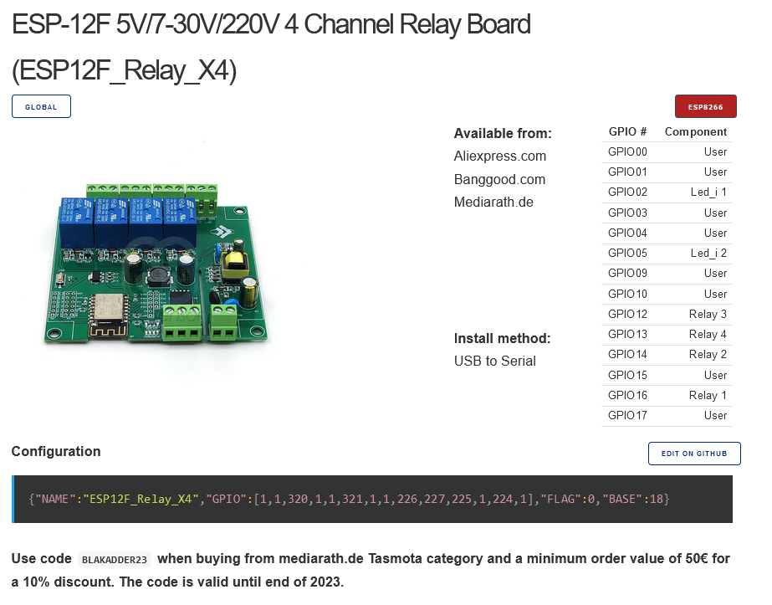
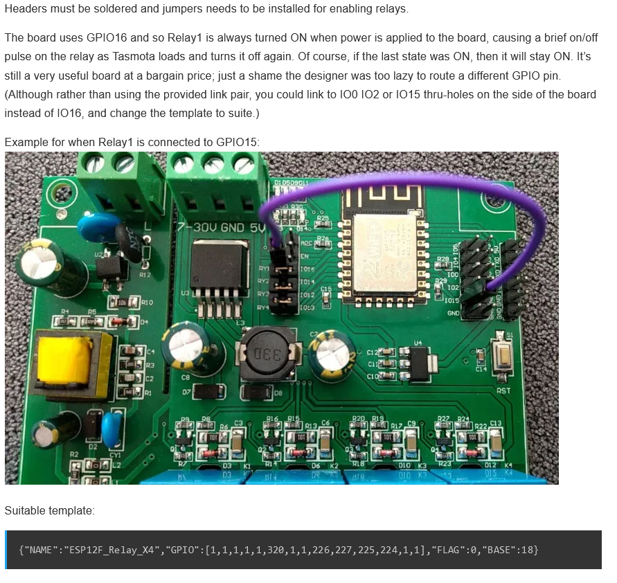
{"NAME":"ESP12F_Relay_X4","GPIO":[1,1,1,1,1,320,1,1,226,227,225,224,1,1],"FLAG":0,"BASE":18}

